**Public Private Partnership Contract Seminar**

**Riyadh, Saudi Arabia**

**7 December 2022**

*Organized by:*

Commercial Law Development Program (CLDP)

**U.S. Department of Commerce**

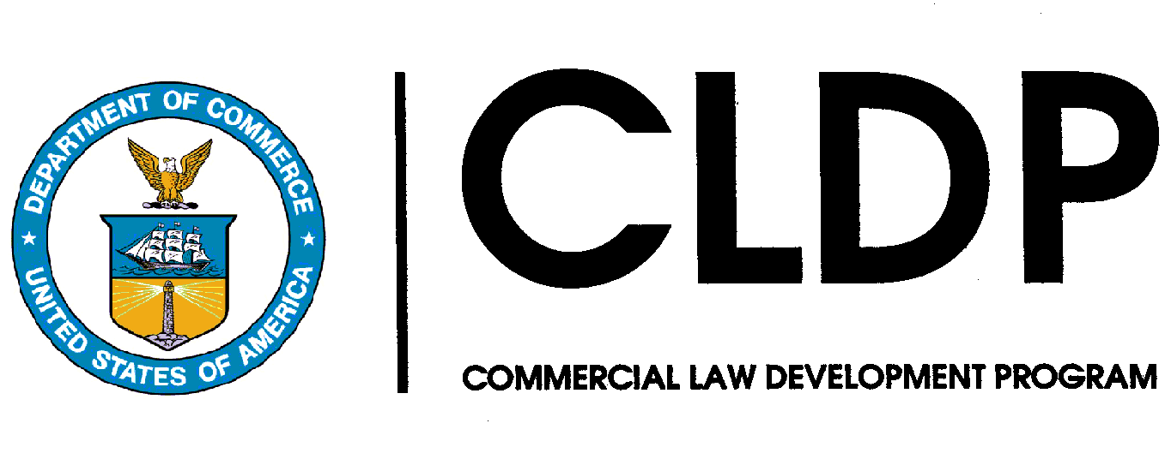

**Expert Advisors:**

Sultan Al Qahtani

Legal Director, National Center for Privatization and Public Private Partnerships (NCP)

sultan.q@ncp.gov.sa

Arthur Smith

Consultant, National Center for Privatization and Public Private Partnerships (NCP)

ASmith@ncp.gov.sa

Don DeAmicis, Professor, Georgetown University Law Center, Don.DeAmicis@law.georgetown.edu

**U.S. Government Officials:**

Eddy Duré, International Program Specialist, Commercial Law Development Program

James Filpi, Senior Attorney, Commercial Law Development Program - +1-202-423-4574

**PROGRAM** **OBJECTIVES**

The US Department of Commerce Commercial Law Development Program (CLDP) aims to improve the legal environment for doing business in countries around the globe, thereby fostering greater political stability and economic opportunities. CLDP consultative services and programs assist political, regulatory, judicial, and commercial leaders to augment their policies, laws and organizational structures.

In recent years, Saudi Arabia has developed new commercial laws to prepare the country for a transformation to a knowledge-based economy that encourages innovation and entrepreneurship. Important to attracting foreign investment and the transfer of knowledge and technology to Saudi Arabia, the Government of Saudi Arabia has developed commercial laws that are in line with international best practices and present Saudi Arabia as an effective partner in the global economy.

The Government of Saudi Arabia’s Vision 2030 is a road map that depends upon implementation roles by the Government of Saudi Arabia as well as the private and public industry sectors in Saudi Arabia. As critical components of the Kingdom of Saudi Arabia (KSA), these communities must coordinate their efforts and reach milestones that will allow Vision 2030 to reach its potential. Commercial laws related to international trade and business are important components to reach the Vision 2030 goals to increase innovation and diversification in the Saudi Arabia economy. In pertinent part, KSA is ambitious about the use of public private partnership (PPP) in order to reach 2030 development and modernization goals.

In order to support the Government of Saudi Arabia to facilitate the economic transformation targeted by Vision 2030, CLDP in collaboration with the Saudi Arabia National Center for Privatization and Public Private Partnership (NCP) and Georgetown University Law Center will conduct a seminar regarding best practices in PPP contracts. During the seminar on 7 December 2022, American Chamber of Commerce Riyadh companies and their lawyers will hear presentations regarding the Saudi Arabia’s PPP Strategy and Effect on Foreign Investment, Private Financing and Procurement of PPPs, and Trends in PPP Contracting in the Gulf.

For more information about this program please contact CLDP Senior Attorney James Filpi at jfilpi@doc.gov +1-202-423-4574.

**PROGRAM** **AGENDA**

**5:00 PM** **Welcoming Remarks & General Introductions**

Speaker: James Filpi, CLDP

**5:15 PM PPP Strategy and Effect on Foreign Investment**

Speaker: Sultan Al Qahtani, NCP

**6:00 PM Private Financing and Procurement of PPPs**

Speaker: Don DeAmicis, Georgetown University Law Center

**6:45 PM Trends in PPP Contracting in the Gulf**

Speaker: James Filpi, CLDP

**7:15 PM End of Program**